Other support available. There are other options that are available to provide support including:
Self Care | For minor grazes, coughs and colds, sore throats and hangovers. | NHS Inform has excellent information available to support you: https://www.nhsinform.scot
Pharmacist | For diarrhea, runny nose and headaches, stings, bites, emergency contraception. Uncomplicated UTIs.
Dentist | Toothache, abscesses, gum disease.
NHS 111 | General advice, medical help or not sure who to call. | Ring 111
Social Services | For advice and help on social matters, including respite care, additional help at home and aids. | 01563 554200
Podiatry | Patients can refer themselves for foot and nail care.  FootcAyr provides a range of Toe-nail cutting clinics. | Direct to Lister Street XHSE on 01563 826361  FootcAyr  Please contact 01292 281800 or email foot@voluntaryactionsouthayrshire.org.uk
Community/ Connector Link Practitioner | Appointments can be arranged here in the surgery with her/him following a referral from your GP
South Ayrshire LIFE etc East and North | Web-site has hundreds of other activities and local services listed. | http://www.southayrshirelife.org  or phone 0800 432 0510 if you don’t have access to the internet
For real life threatening emergencies such as those below – RING 999
- Chest pain (suspected heart attack)
- Suspected stroke
- Suspected meningitis
- Anaphylactic shock (severe allergy)
- Heavy bleeding or deep lacerations
- Fluctuating levels of consciousness or completely unconscious
- Difficulty breathing or stopped breathing with a change in colour
- New seizure, fit or uncontrollable shaking

For immediately serious conditions such as the following, GO TO Emergency Department (A&E) IMMEDIATELY
- A fever and lethargic (drowsy) child
- A feverish and floppy (unresponsive) infant
- Difficulty breathing
- Sudden, severe abdominal pain
- Accidental or intentional overdose of medication
- Trauma (including falls) and possible broken bones or road traffic accident

Home Visiting at Dr Sardar & Partners
Making Best use of your GP Practice

Our GP Practice is keen that we make best use of our clinical staff allowing them to provide the most appropriate care to those most in need.

For the vast majority of patients attending an appointment at the Surgery is the best option for them and for the Practice staff. Attending a surgery allows our clinical team to see many more patients in a day than if we are undertaking home visits. A doctor could see 4-6 other equally needy patients in the time it takes for a home visit.
Appropriate Unsuitable

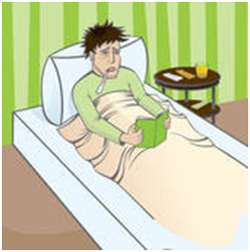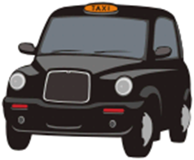

Bedbound
No transport or money
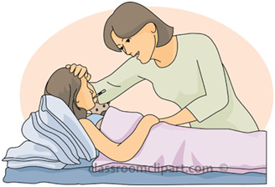
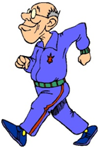

Terminally ill
Children, young people and
anyone who is mobile
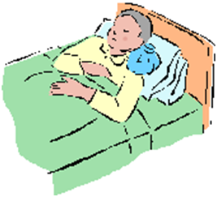

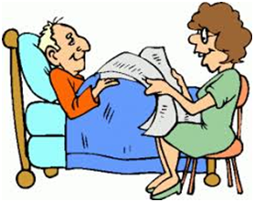

Would come to
serious harm if moved

THE SMALL PRINT
- Patients do not have an automatic right to a home visit
- Doctors are only able to consider home visits for medical reasons only
- If you think you qualify for a home visit, please ring before 9.30 am
- All visits requested will be medically assessed to check if appropriate
Social reasons or
for convenience

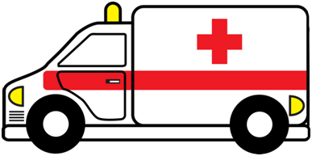

Other help more
appropriate

Home visits, whilst convenient for patients, actually offer a poorer standard of care compared to surgery consultations. This is because of:-

- Poor facilities (e.g.:- soft beds, poor lighting, lack of hygiene)
- Lack of records and chaperones (required for safe care and examination)

We have noticed that many patients are requesting visits that are inappropriate or unnecessary. This is having a negative impact upon other aspects of our service. Calling the doctor out unnecessarily takes them away from the patient who may be in more clinical need. Most of the consultations during home visits could easily and safely be carried out in the surgery. Because patients might not know this, we are letting you know our policy on home visits.

Home visits are entirely appropriate for:

- Terminally ill patients – we have no problems at all seeing those who are at most clinical need
- Truly bedbound patients – we have no problem seeing those who are confined to bed
- Patients who are so poorly they would be harmed if moved – we have no problems at all seeing those who are at most clinical need

Home visits are not appropriate for the following reasons:

- Children, young people or anyone who is mobile— young children can be carried and can be seen quickly in the surgery.
- Lack of money or transport—this is not a medical responsibility. It is up to the patient and/or families/friends to organise transport
- Lack of childcare
- People who have been drinking alcohol and not able to drive – this is not a medical responsibility
- Can’t get out due to bad weather—we are also affected by snow, ice or bad weather.
- Timed visits between hairdressing and shopping appointments—patients who are clearly mobile are taking doctors and nurses away from patients more in need.
- Well but need a check over to make sure everything is all right—our priority is seeing the unwell.
- Other help more appropriate - e.g., if you think you are having a heart attack or stroke please ring 999.

Some Myths about Home Visits (all of these are not true)

- “It’s my right to have a home visit” - under GP terms of service, it is actually up to the doctor to decide, in their reasonable opinion, where a consultation should take place.
- “ I should get a visit because I’m old” - our clinical work should not
discriminate simply based on age alone.
- “I can’t bring little Freddie out in this weather” - no-one will be harmed by being wrapped up and brought in.
- “The doctor needs to check I’m ready to go into hospital/have a ward to go to” -Paramedics can provide initial lifesaving care and patients will be dealt with appropriately in A&E Departments.
- “I’m housebound” - being housebound does not always prevent use of transport.
- “I live in a care home so I get a visit” - many such patients still go to hospital outpatients and take trips out.
- “Can the GP just pop out and see me” - we have fully booked surgeries and cannot simply drop everything to visit people urgently.

If you think you may need a home visit

We would kindly ask any patient who is mobile (including using a walking aid, wheelchair or scooter) to see us in surgery. If you are poorly and think you need an urgent same day visit, please ring your request through to the surgery on 01563 522118 before 10 am on the day (if possible). The doctor will always consider your request.

If we visit you and feel that your request was inappropriate

If we feel that your visit request was inappropriate, we may inform you so that you may use our services more appropriately in the future. Please do not be offended, as we have a duty to use our limited resources effectively for the safety and benefit of ALL patients.

